**Dotnet core Training Assessment**

**05-July-2024**

**Codes + Screenshots**

**Arihant Kapoor**

**Question 1: Core WebApi**

Please find the below codes and output screenshots for the whole webapi application.

**Command to make new webapi project:**

dotnet new webapi --name eProductApi

Various packages should be added for this questions:

The command is

dotnet add package <package_name>

Packages Name :-

microsoft.entityframeworkcore

microsoft.entityframeworkcore.design

microsoft.entityframeworkcore.sqlserver

microsoft.entityframeworkcore.tools

AutoMapper.Extensions.Microsoft.DependencyInjection

Now, the codes for various files are attached along with their name

appsettings.json

{

  "Logging": {

    "LogLevel": {

      "Default": "Information",

      "Microsoft.AspNetCore": "Warning"

    }

  },

  "AllowedHosts": "*",

  "ConnectionStrings": {

    "connectionString" : "data source = (localdb)\\ProjectModels; database = eProductApiDB; integrated security = true"

  }

}

Product.cs

using System.ComponentModel.DataAnnotations;

namespace eProductApi.Model

{

    public class Product

    {

        [Key]

        public int ProductID {get;set;}

        public string ProductName {get;set;}

        public int ProductPrice {get;set;}

    }

}

ProductDTO.cs

namespace eProductApi.Model

{

    public class ProductDTO

    {

        public int ProductID { get; set; }

        public string ProductName { get; set; }

        public int ProductPrice { get; set; }

    }

}

ProductMapper.cs

using AutoMapper;

namespace eProductApi.Model

{

    public class ProductMapper: Profile

    {

        public ProductMapper(){

            //source, destination mapping

            CreateMap<ProductDTO,Product>();

        }

    }

}

ProductDBContext.cs

using eProductApi.Model;

using Microsoft.EntityFrameworkCore;

namespace eProductApi.DAL

{

    public class ProductDBContext: DbContext

    {

        public ProductDBContext(DbContextOptions dbContextOptions) : base(dbContextOptions)

        {

        }

        public DbSet<Product> Products {get;set;}

    }

}

DynamicMigrationProduct.cs

using eProductApi.DAL;

using Microsoft.EntityFrameworkCore;

namespace eProductApi.DynamicMigrations

{

    public static class DynamicMigrationProduct

    {

        //Extension method to be used in program.cs

        public static void DynamicMigration(this IApplicationBuilder app){

           using(var obj = app.ApplicationServices.CreateScope()){

            //creating database without running any

               obj.ServiceProvider.GetService<ProductDBContext>().Database.Migrate();

           }

        }

    }

}

IProductRepository.cs

using eProductApi.Model;

namespace eProductApi.Repository

{

    public interface IProductRepository

    {

         Task<IEnumerable<Product>> GetAllProducts();

         Task<IEnumerable<Product>> AddProduct(Product productDTO);

         Task<IEnumerable<Product>> DeleteProduct(int id);

         Task<IEnumerable<Product>> UpdateProduct(Product productDTO);

    }

}

ProductRepository.cs

using eProductApi.DAL;

using eProductApi.Model;

using Microsoft.EntityFrameworkCore;

namespace eProductApi.Repository

{

    public class ProductRepository : IProductRepository

    {

        ProductDBContext _context;

        public ProductRepository(ProductDBContext context){

            _context = context;

        }

        public async Task<IEnumerable<Product>> AddProduct(Product product)

        {

           _context.Products.Add(product);

           _context.SaveChanges();

           return await _context.Products.ToListAsync();

        }

        public async Task<IEnumerable<Product>> DeleteProduct(int id)

        {

            _context.Products.Remove(_context.Products.Find(id));

            _context.SaveChanges();

            return await _context.Products.ToListAsync();

        }

        public async Task<IEnumerable<Product>> GetAllProducts()

        {

           return await _context.Products.ToListAsync();

        }

        public async Task<IEnumerable<Product>> UpdateProduct(Product product)

        {

            Product product1 = _context.Products.Find(product.ProductID);

            product1.ProductName = product.ProductName;

            product1.ProductPrice = product.ProductPrice;

            _context.Products.Update(product1);

            _context.SaveChanges();

            return await _context.Products.ToListAsync();

        }

    }

}

ProductControllers.cs

using AutoMapper;

using eProductApi.Model;

using eProductApi.Repository;

using Microsoft.AspNetCore.Mvc;

using Microsoft.JSInterop.Infrastructure;

namespace eProductApi.Controllers

{

    [ApiController]

    [Route("api/[controller]")]

    public class ProductController : ControllerBase

    {

        IMapper _mapper;

        IProductRepository _productRepo;

        public ProductController(IMapper mapper, IProductRepository productRepo)

        {

            _mapper = mapper;

            _productRepo = productRepo;

        }

        [HttpGet("GetAllProducts")]

        //Api end Point for Getting all the products present in the database

        public async Task<IActionResult> GetAllProducts(){

            return Ok(await _productRepo.GetAllProducts());

        }

        [HttpPost("PostProduct")]

        //Api end point for Adding new product

        public async Task<IActionResult> AddProduct(ProductDTO productDTO){

            Product product = _mapper.Map<Product>(productDTO);

            return Ok(await _productRepo.AddProduct(product));

        }

        [HttpDelete("DeleteProduct")]

        //Api end point for deleting a product

        public async Task<IActionResult> DeleteProduct(int id){

            return Ok(await _productRepo.DeleteProduct(id));

        }

        [HttpPut("UpdateProduct")]

        //Api end point for updating a product

        public async Task<IActionResult> UpdateProduct(ProductDTO productDTO){

            Product product = _mapper.Map<Product>(productDTO);

            return Ok(await _productRepo.UpdateProduct(product));

        }

    }

}

Program.cs

using eProductApi.DAL;

using eProductApi.DynamicMigrations;

using eProductApi.Model;

using eProductApi.Repository;

using Microsoft.EntityFrameworkCore;

var builder = WebApplication.CreateBuilder(args);

// Add services to the container.

// Learn more about configuring Swagger/OpenAPI at https://aka.ms/aspnetcore/swashbuckle

builder.Services.AddEndpointsApiExplorer();

builder.Services.AddSwaggerGen();

//AddControllers to the service

builder.Services.AddControllers();

//Adding ProductDBContext

builder.Services.AddDbContext<ProductDBContext>(options=>options.UseSqlServer(builder.Configuration.GetConnectionString("connectionString")));

//Adding Automapper to the service

builder.Services.AddAutoMapper(typeof(ProductMapper));

//Doing IOC of Repository classes

builder.Services.AddTransient<IProductRepository, ProductRepository>();

var app = builder.Build();

// Configure the HTTP request pipeline.

if (app.Environment.IsDevelopment())

{

    app.UseSwagger();

    app.UseSwaggerUI();

}

//using dynamic migrations

app.DynamicMigration();

//configuring end points

app.MapControllers();

app.UseHttpsRedirection();

app.Run();

Please find the folder structure for the project

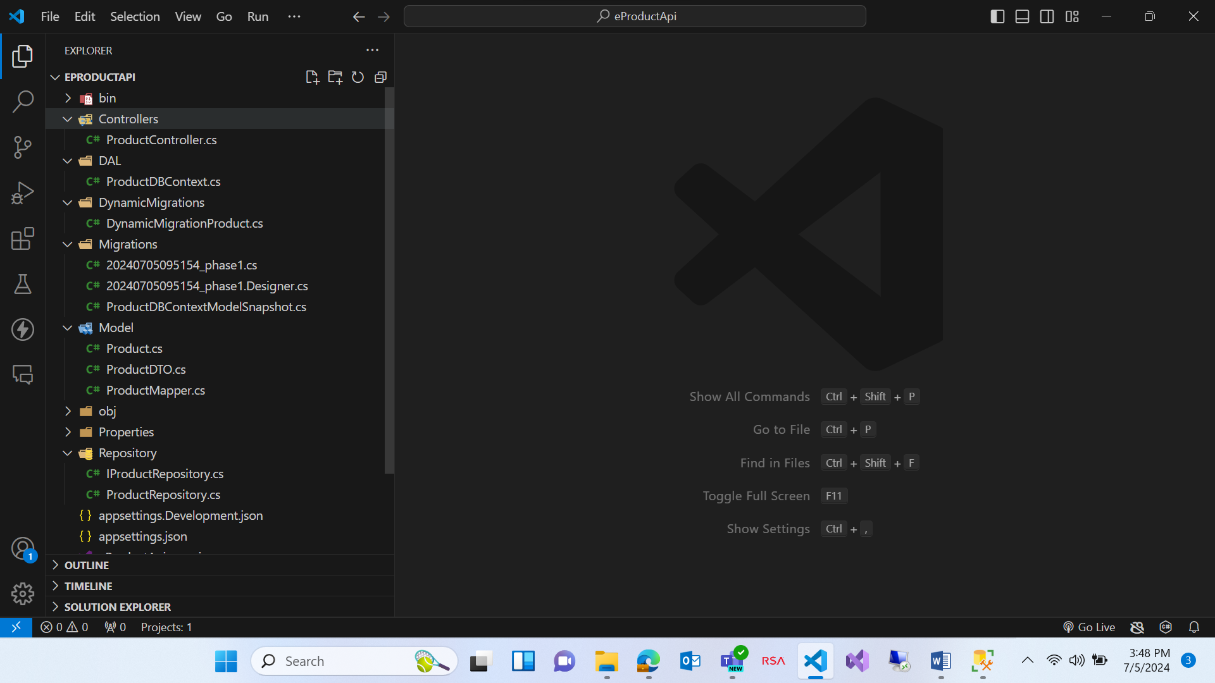

After creating all the files/codes, we need to run two commands

dotnet ef migrations add phase1

dotnet watch run

After these two, swagger will get opened and database will get created along with the tables.

Please find the output of Swagger

**Posting a new Product**

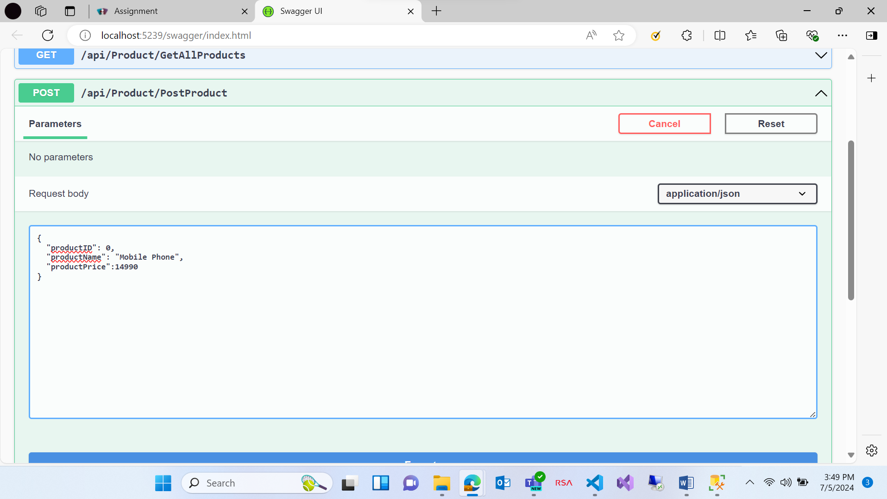

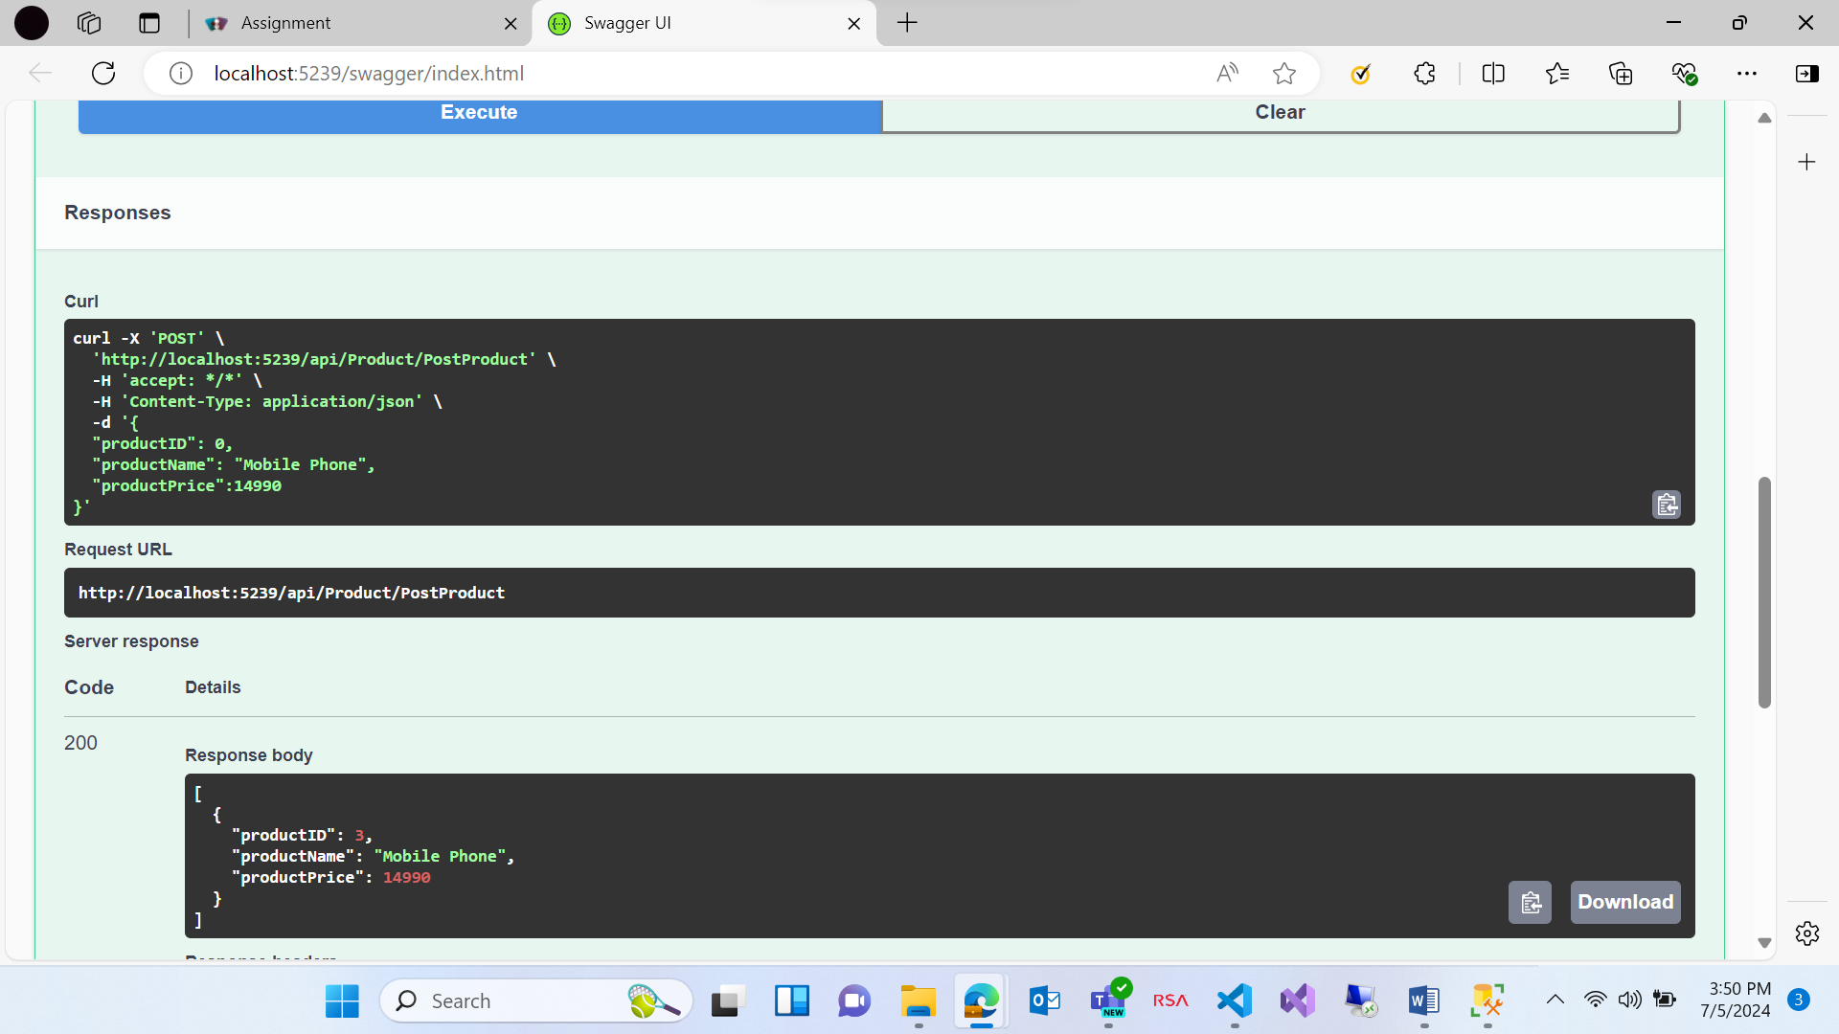

**Updating the existing product**

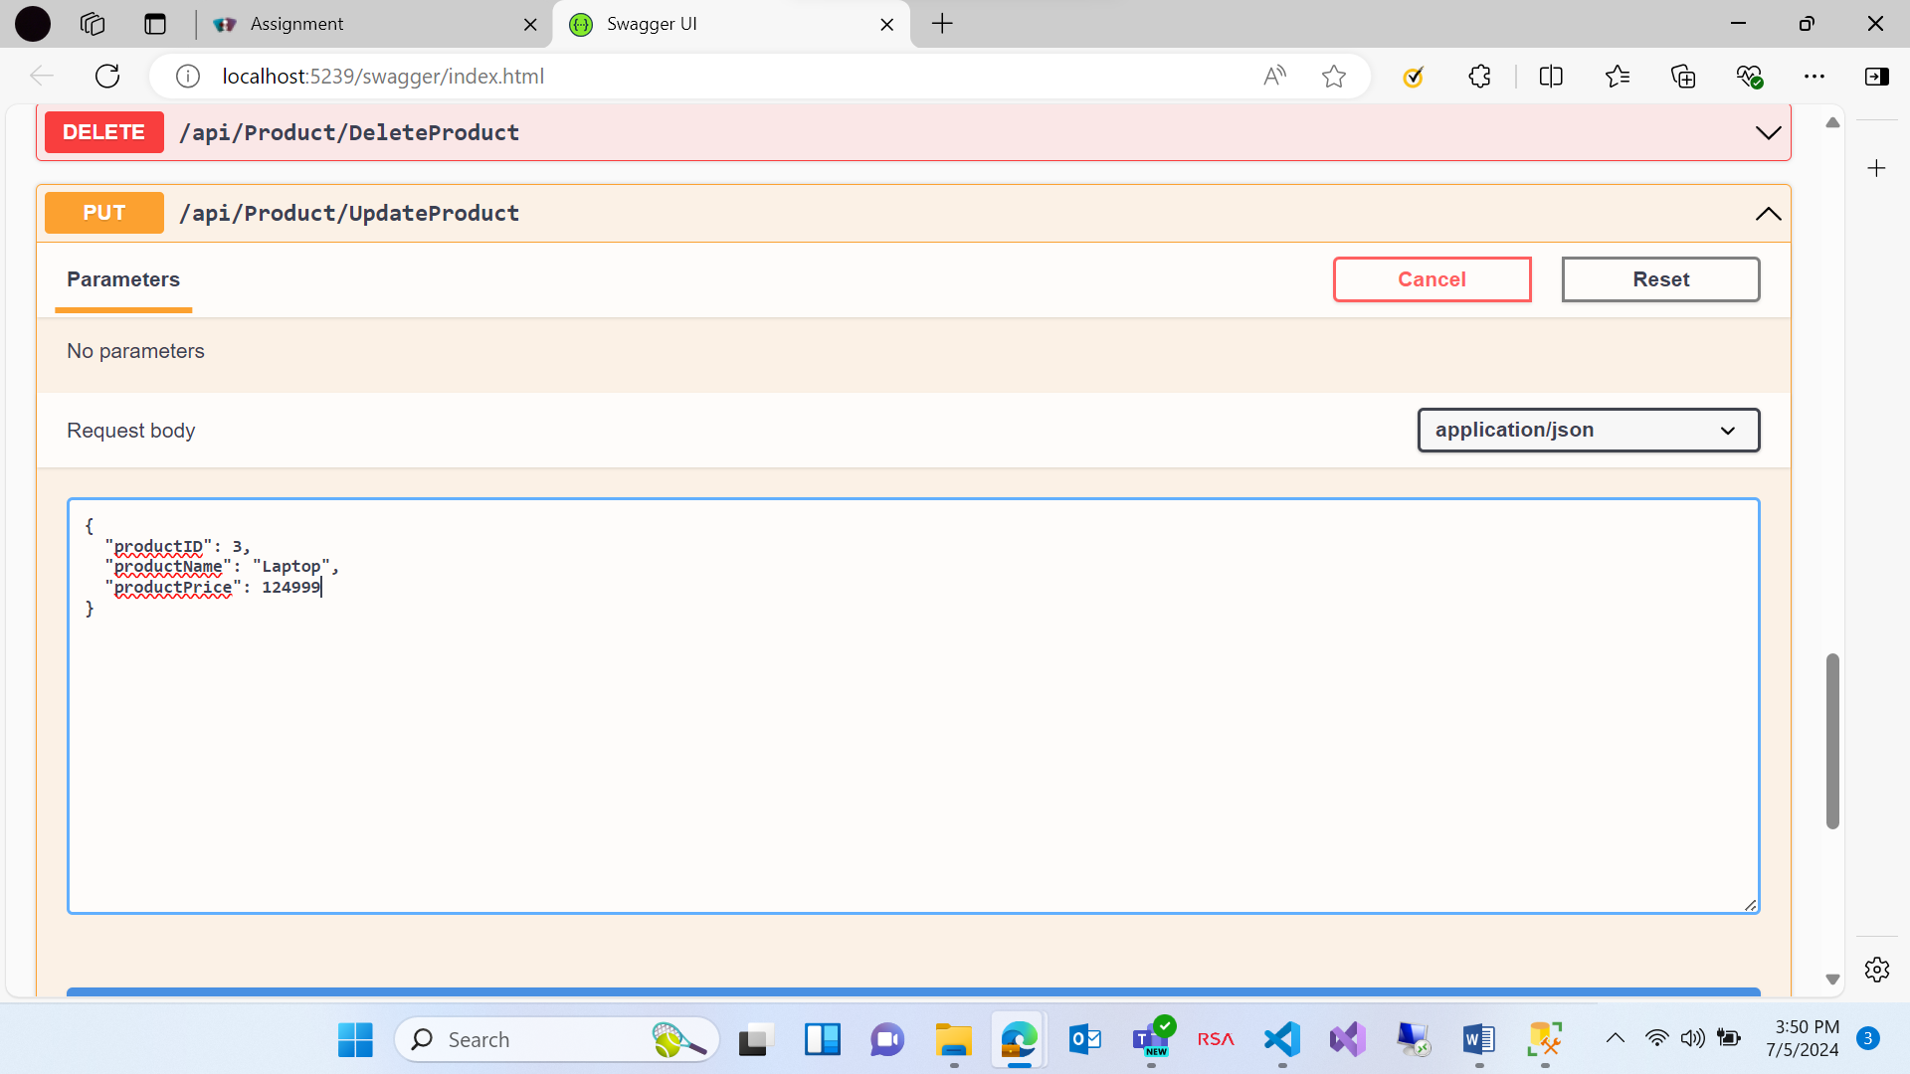

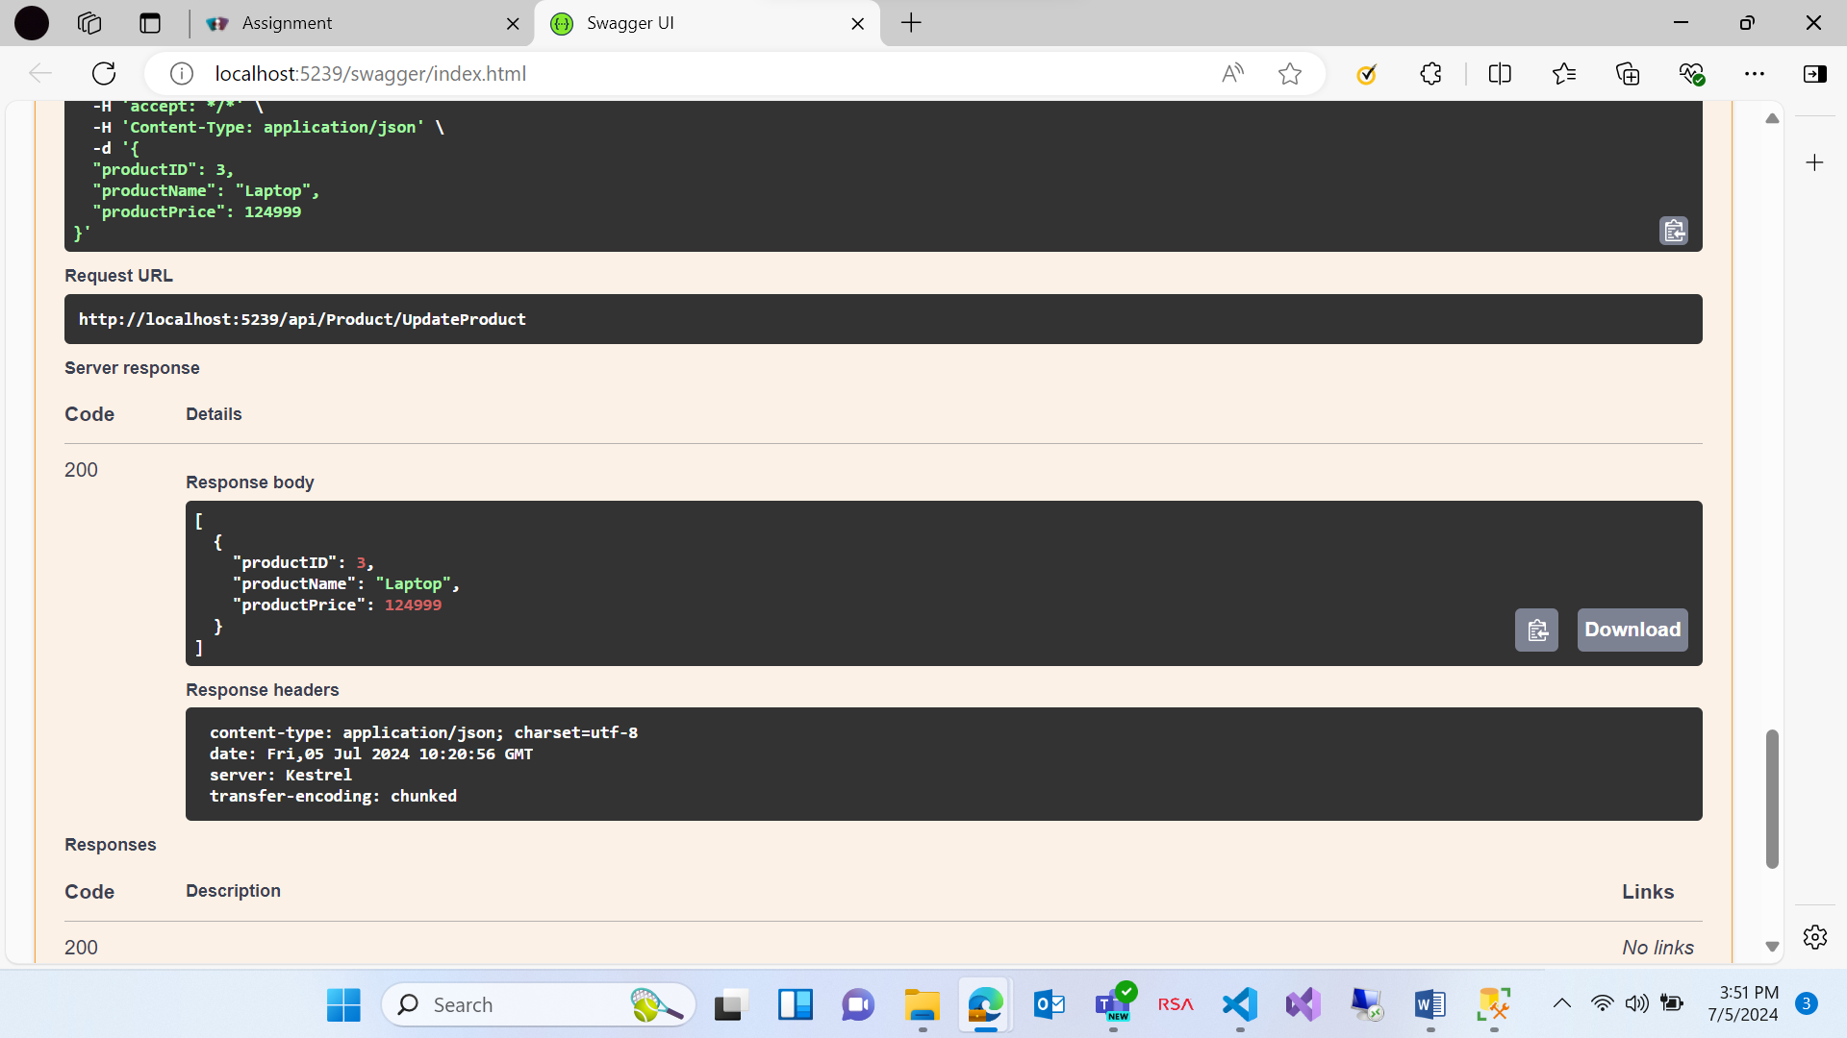

**Getting All the products**

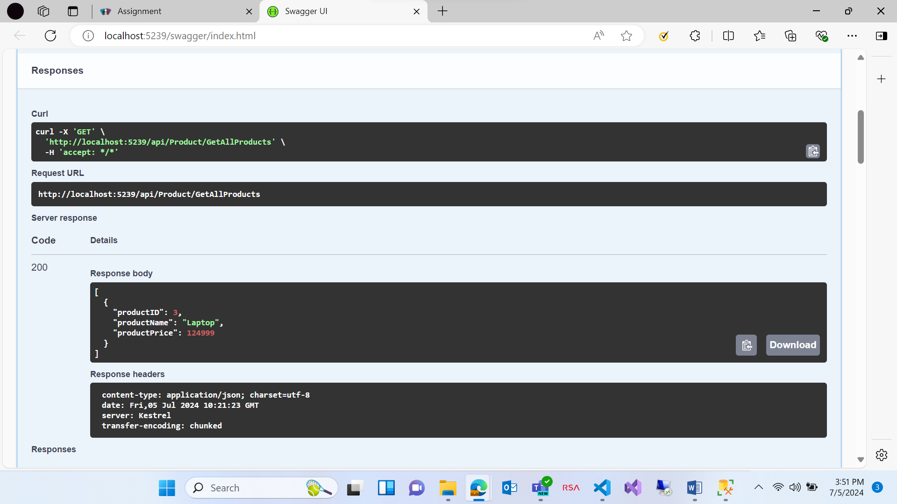

**Deleting a product**

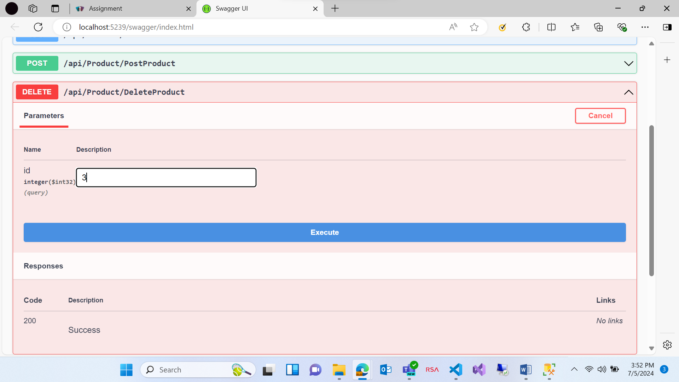

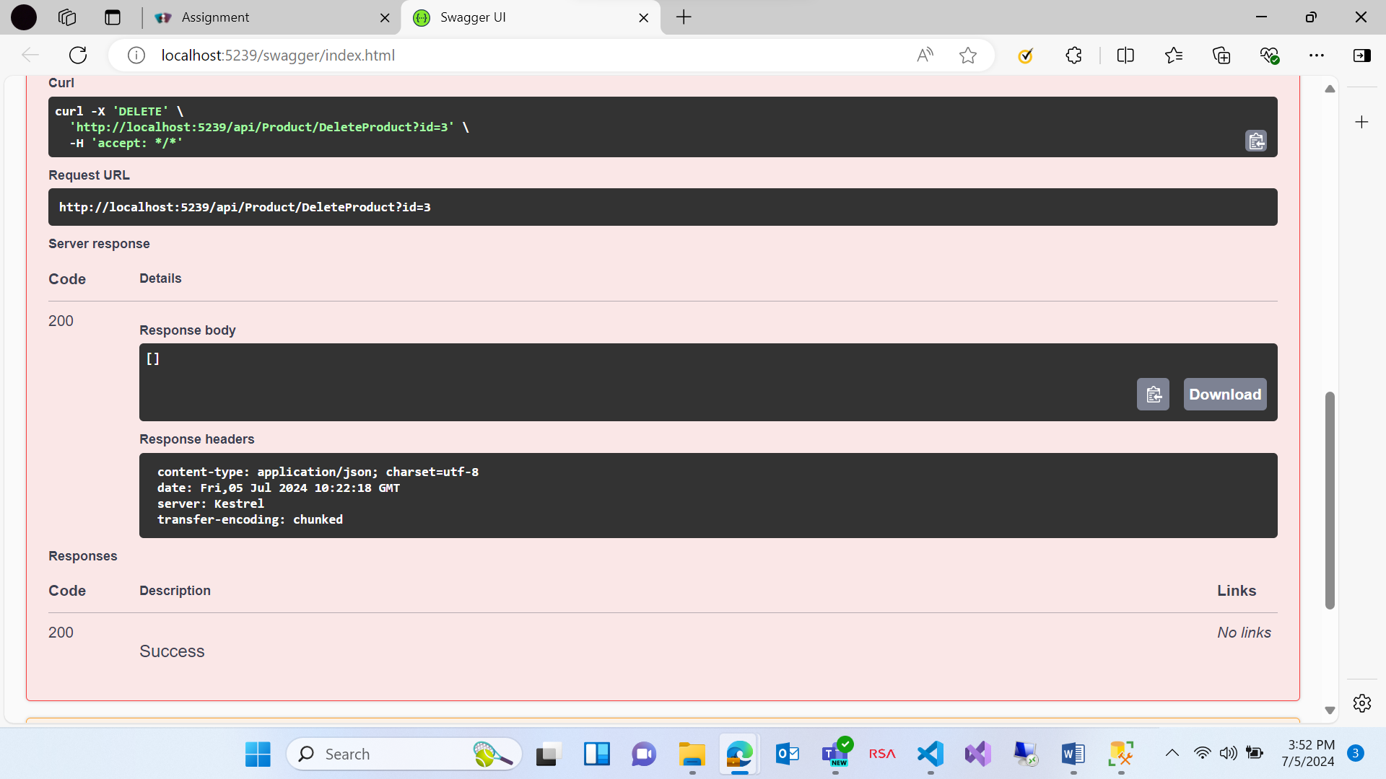

**Question 2: Azure**

Please find the screenshots for Azure question

All the screenshots contain steps that need to be followed for this question i.e. creating a VM, storage container and webapp

Creating a VM:

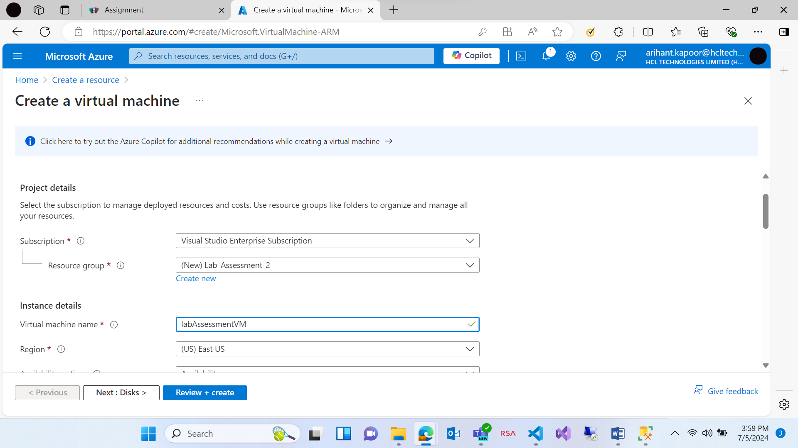

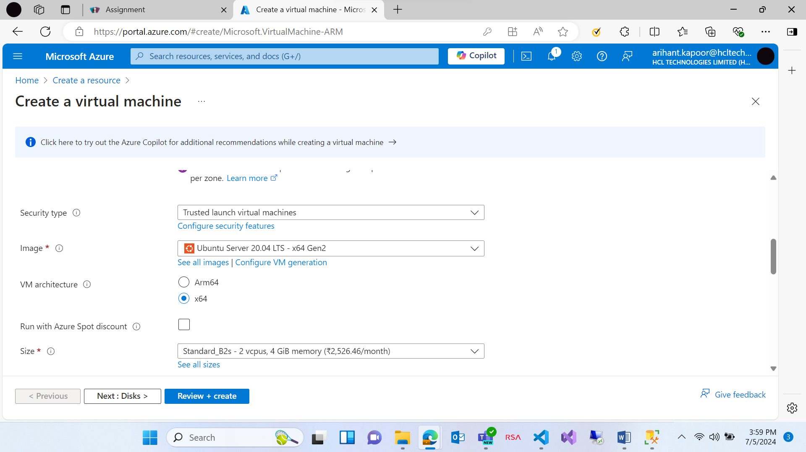

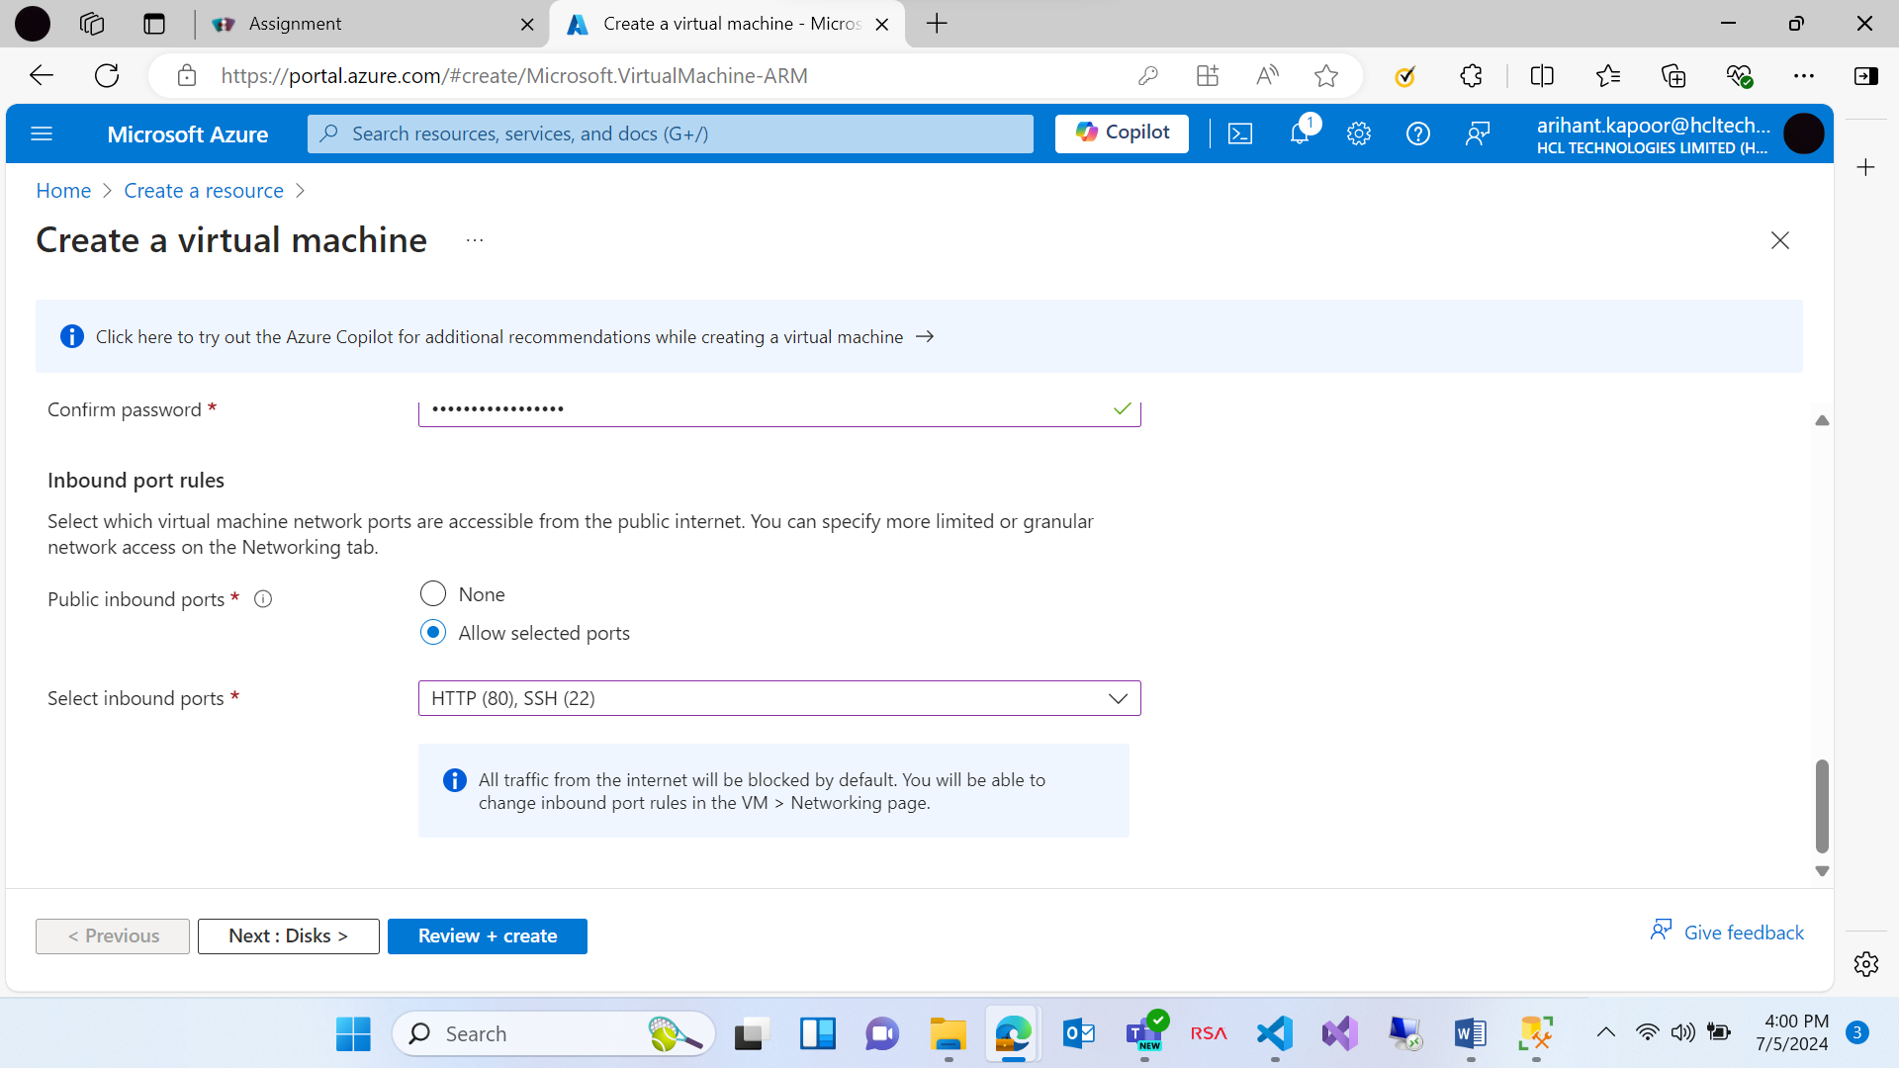

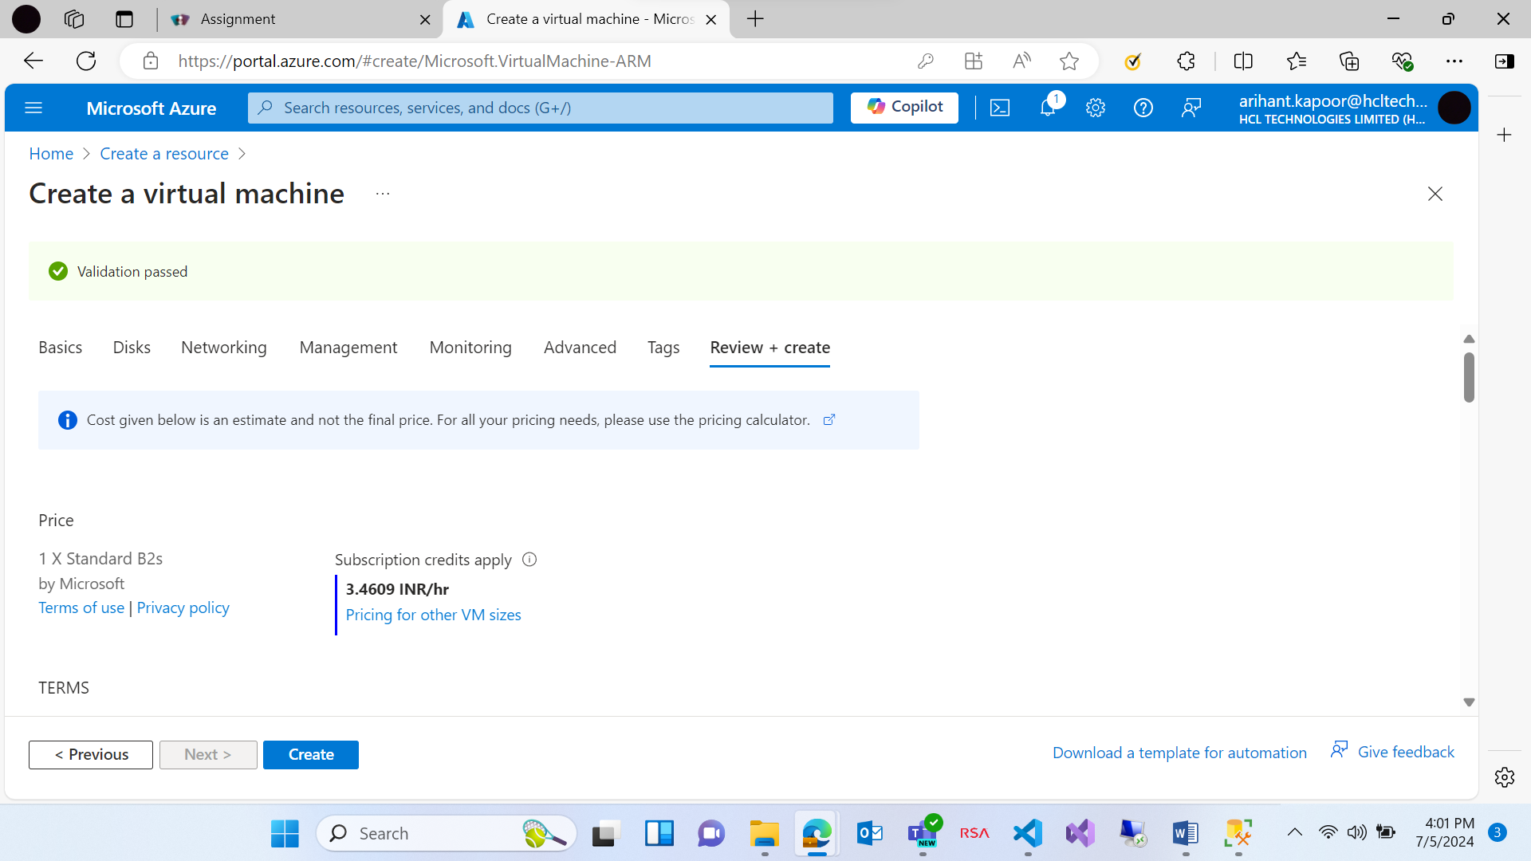

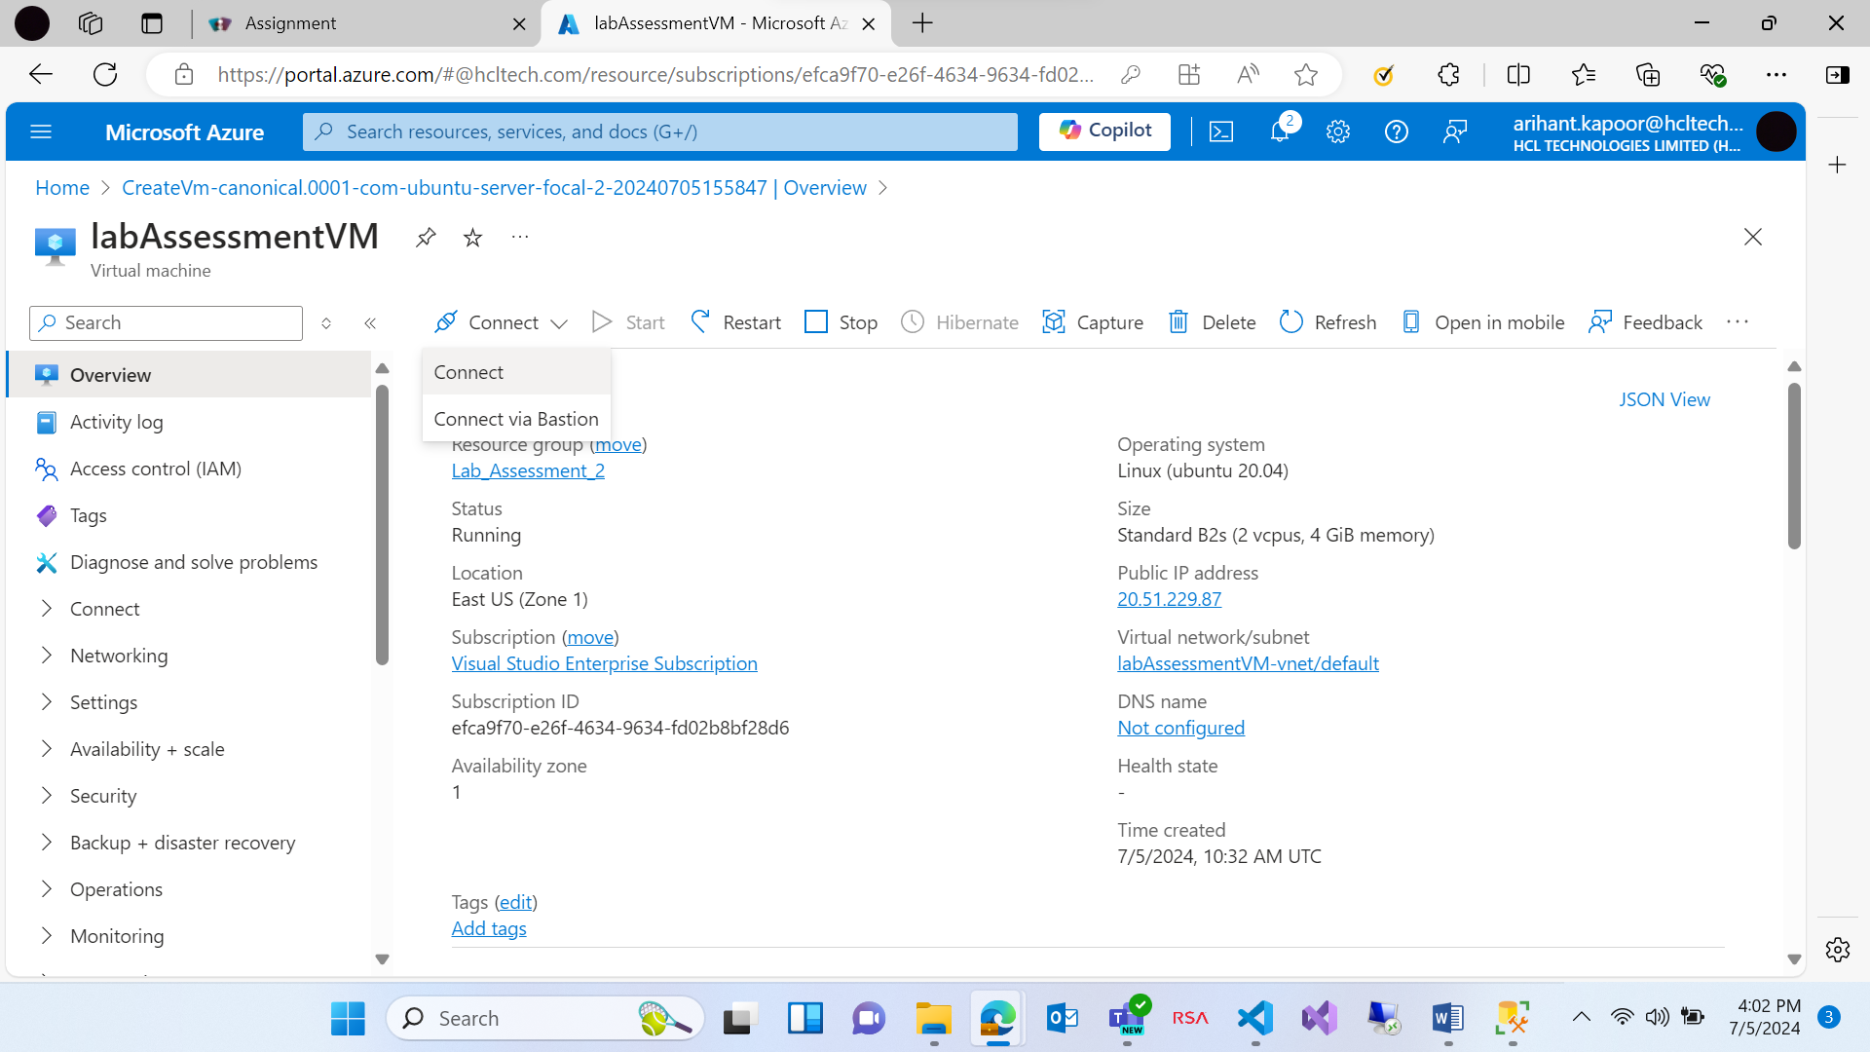

**Installing a server on Linux VM. For that we need to connect it and after connecting, we need to run 3 commands on serial console.**

**sudo apt update**

**sudo apt install apache2**

**sudo systemctl start apache2**

**After this the server will start and the public i.p. address is accessible.**

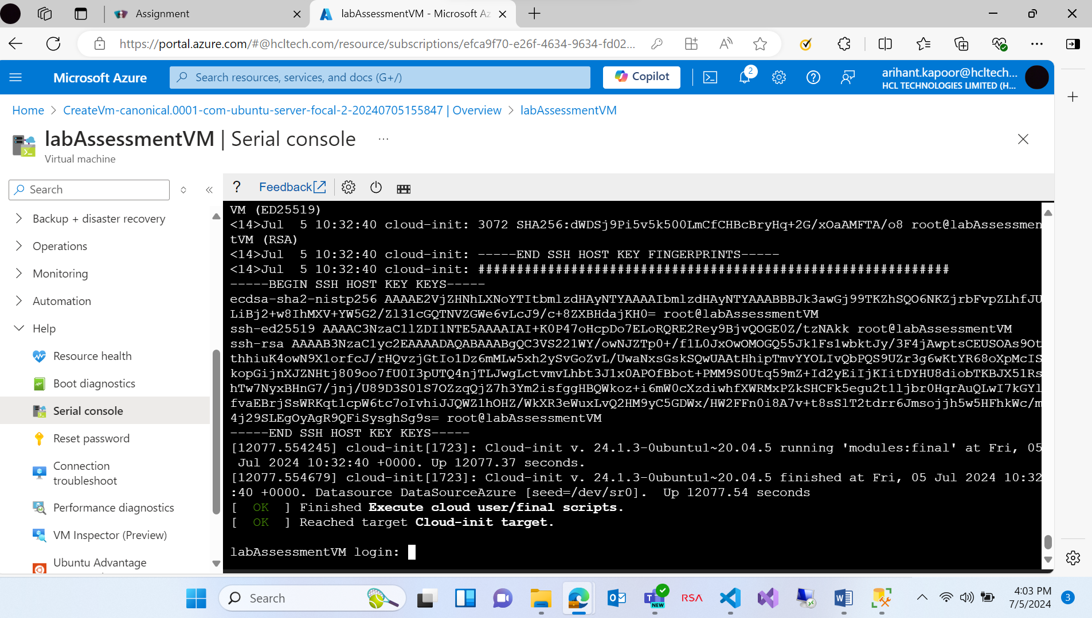

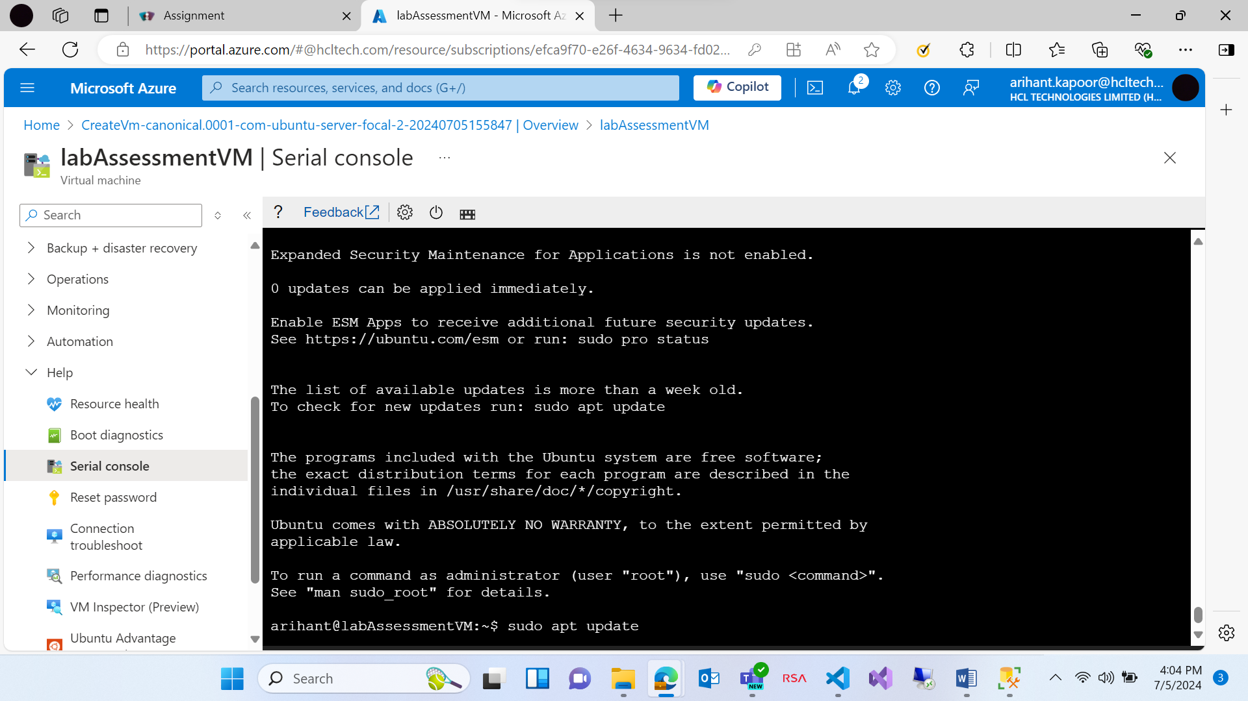

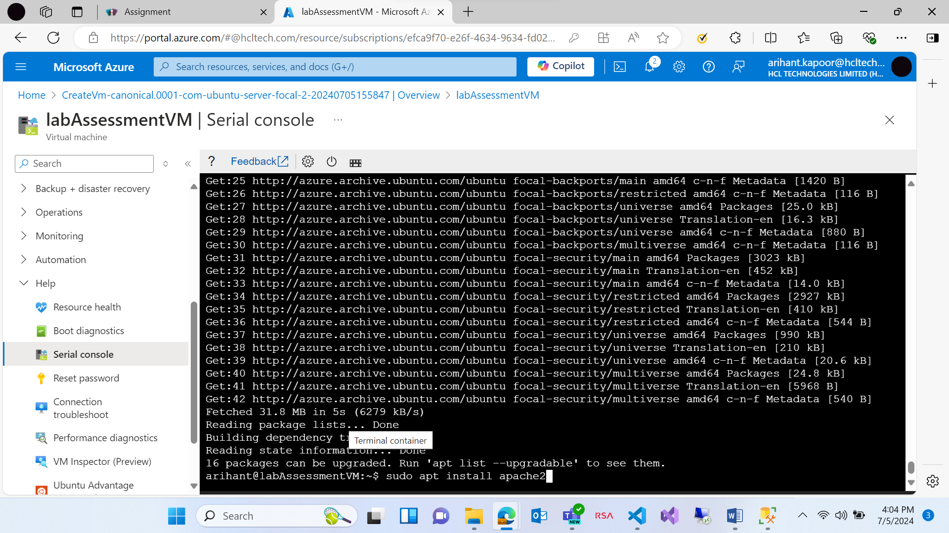

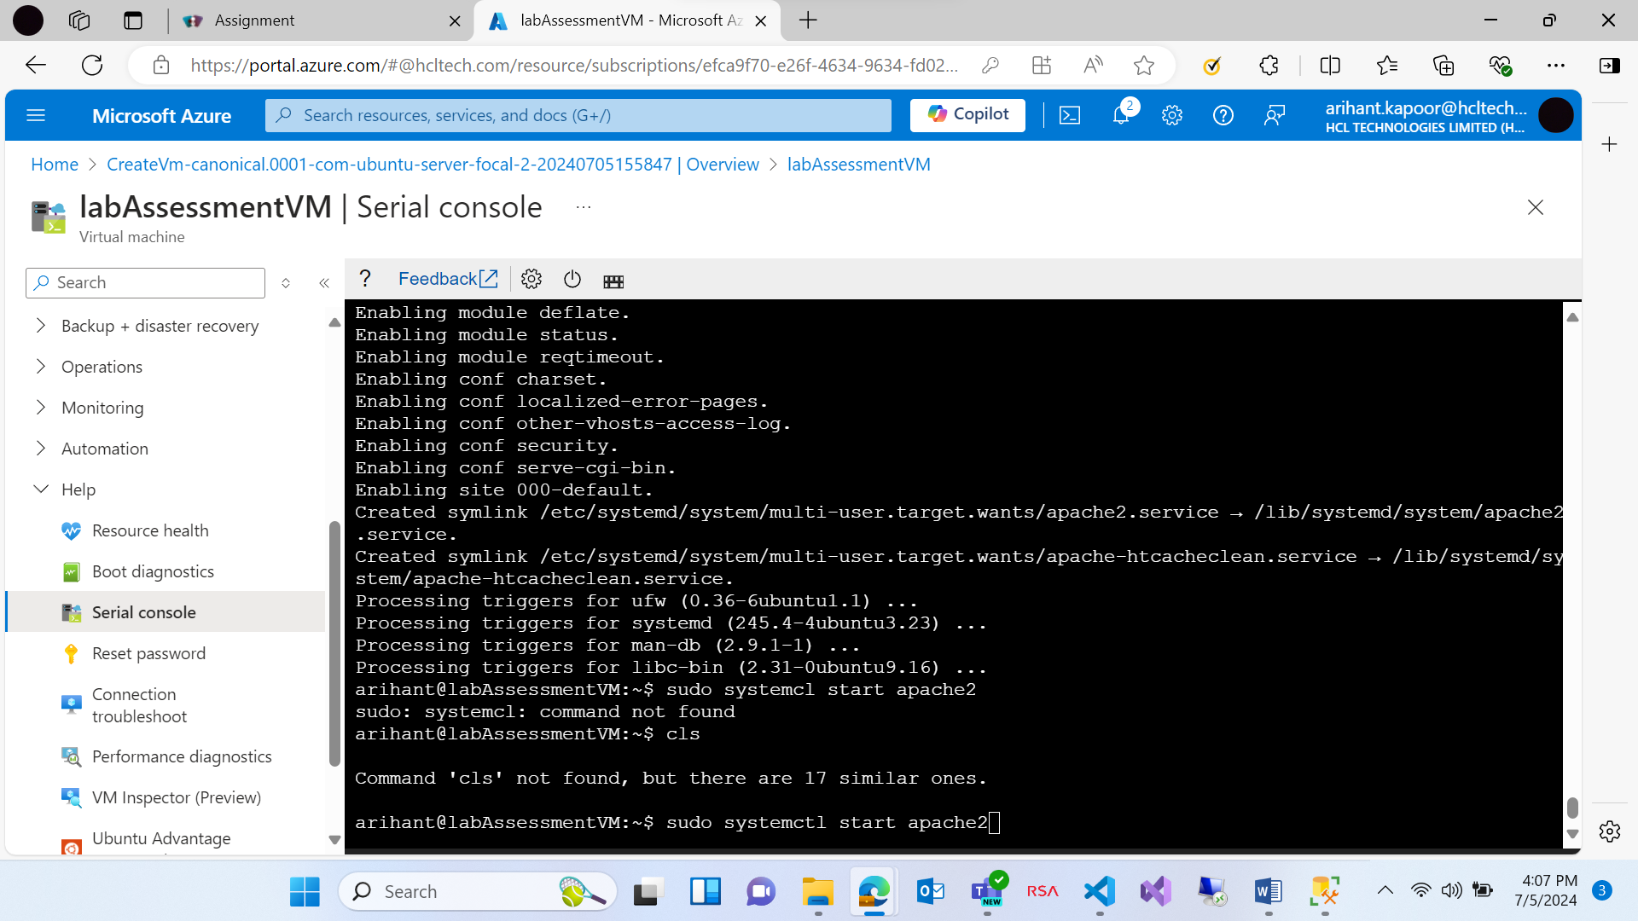

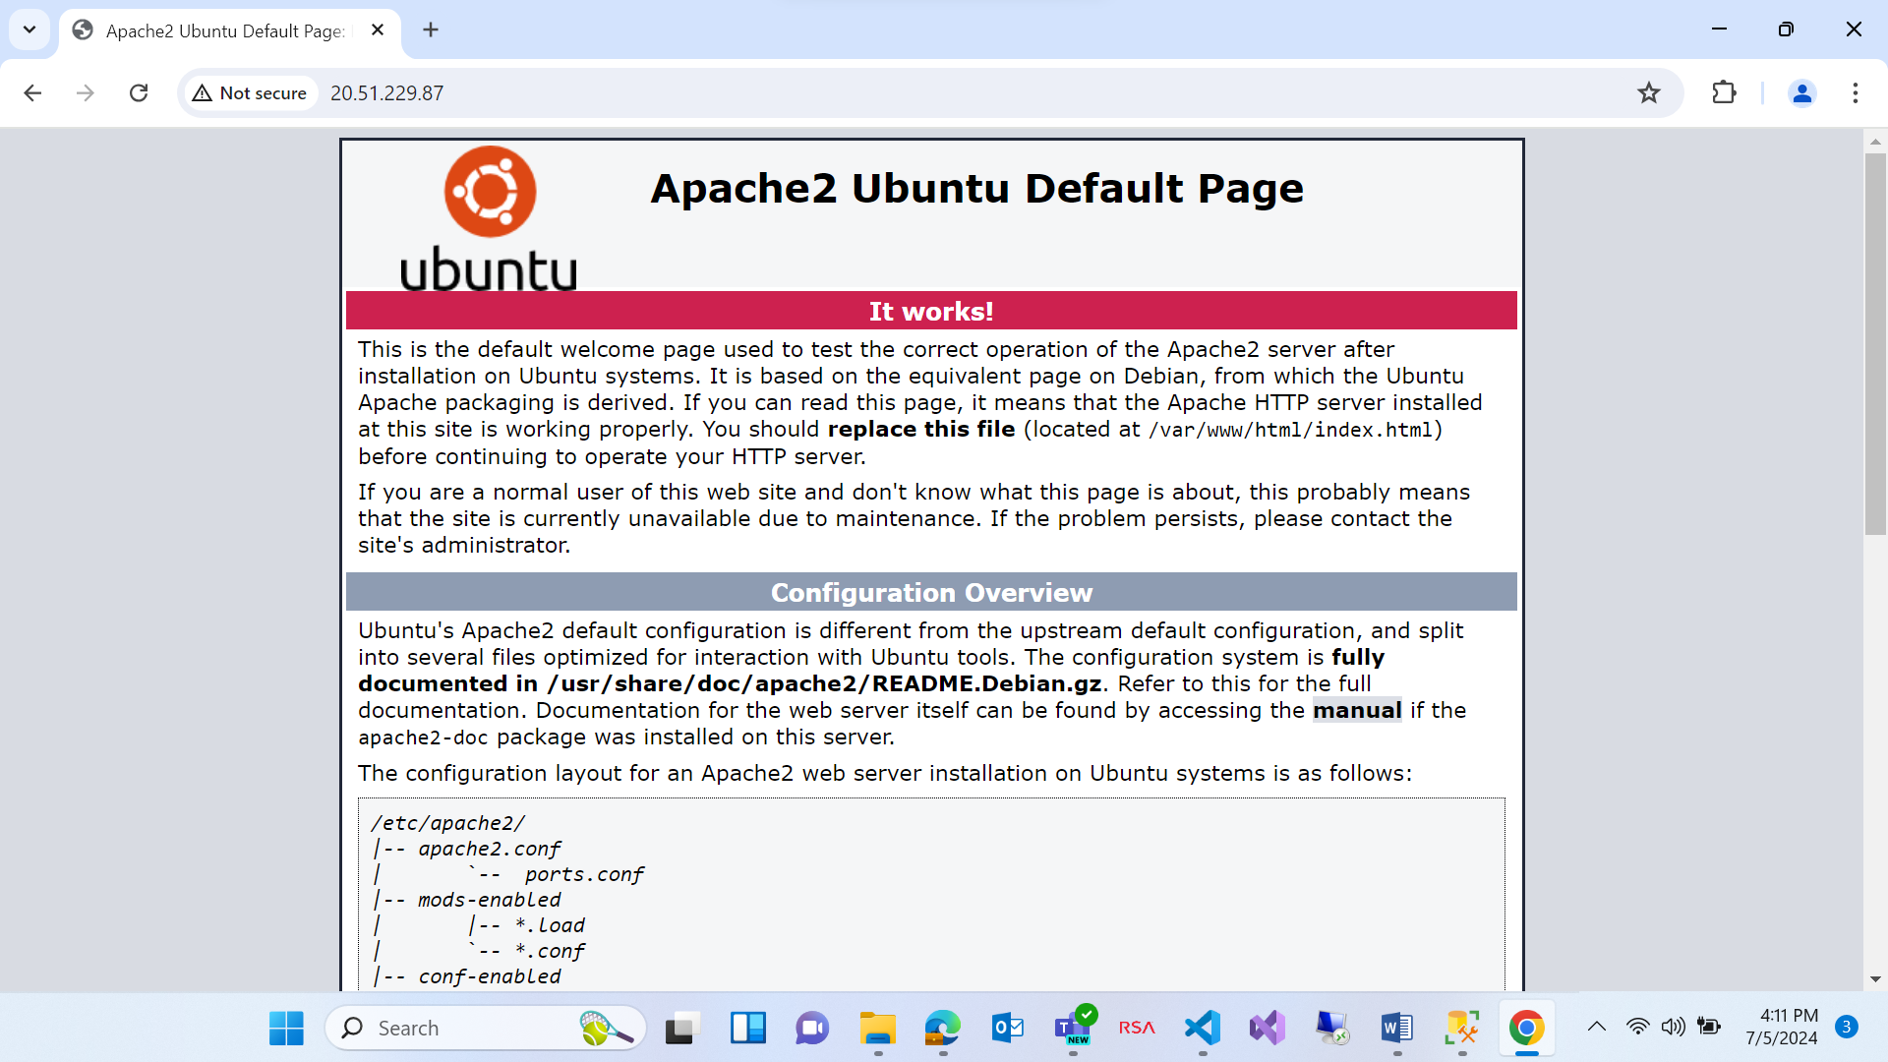

After work is done, please stop the VM otherwise it will have an impact on cost/credits of azure account.

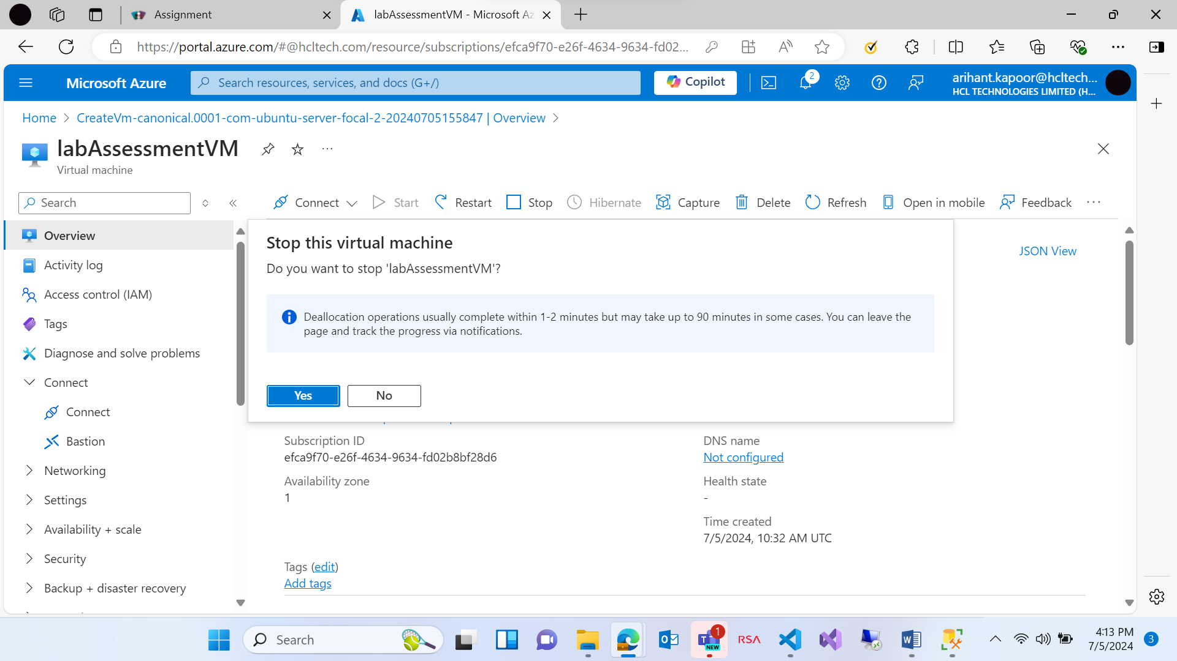

Creating a Storage account, Blob Container, uploading a file, creating a table

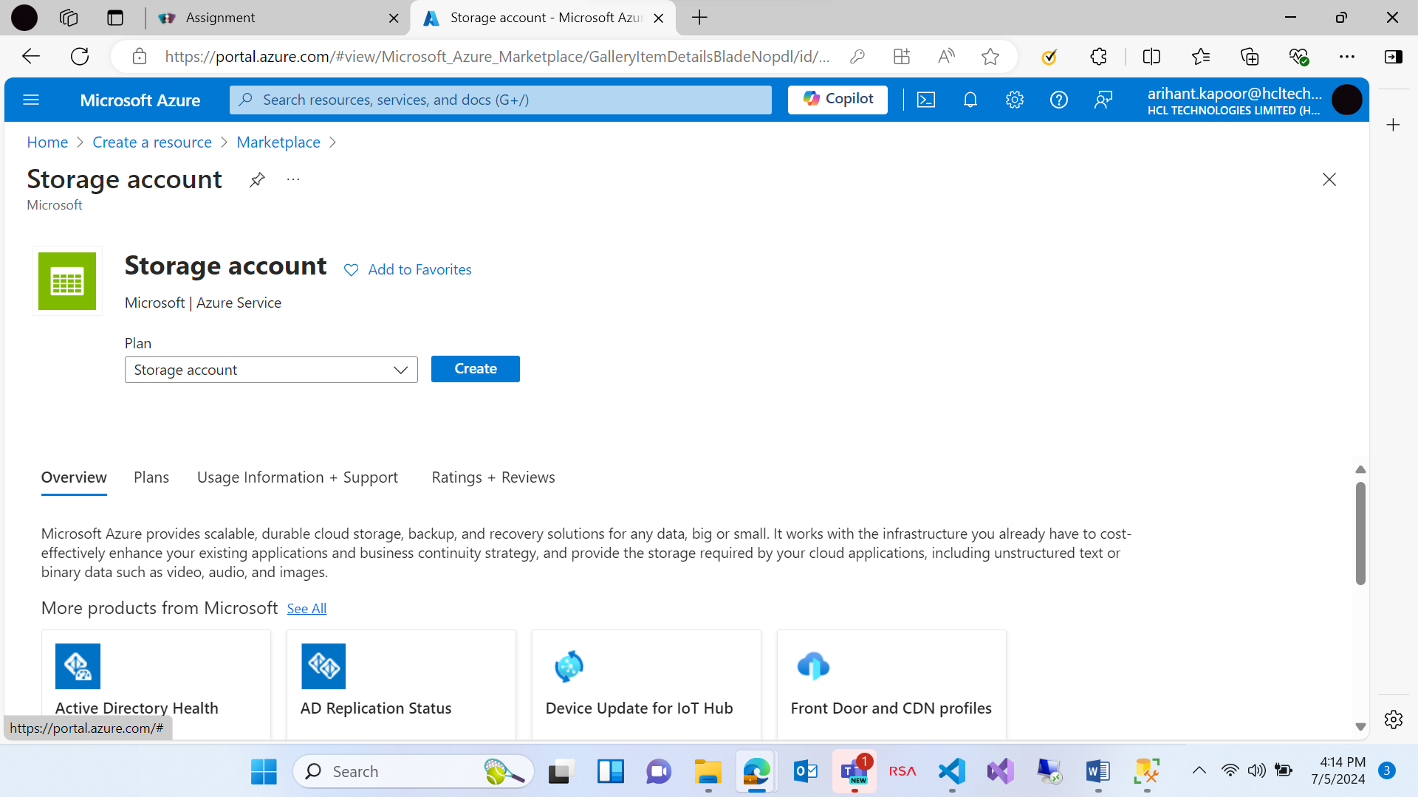

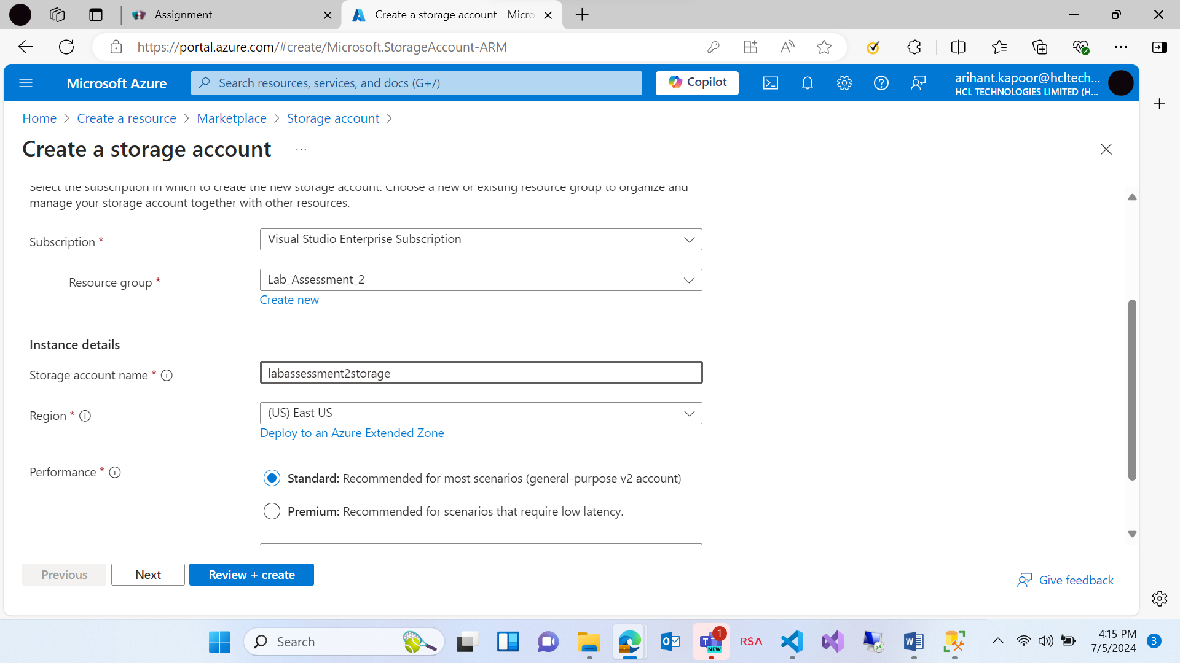

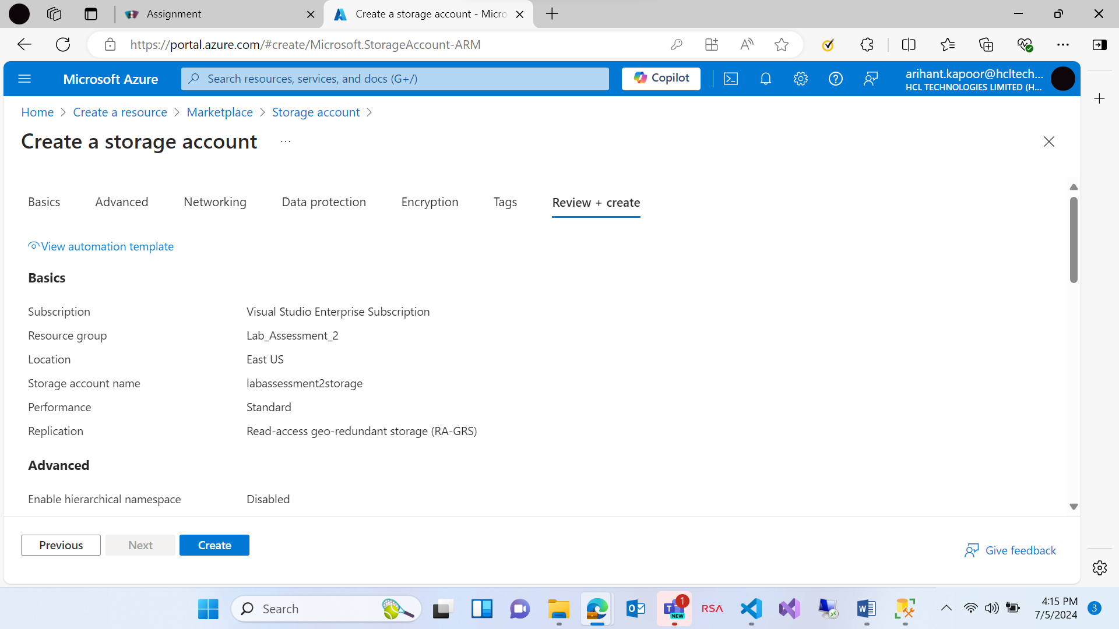

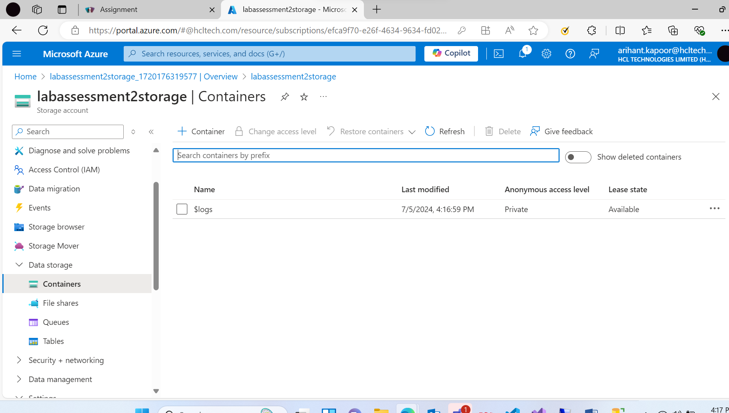

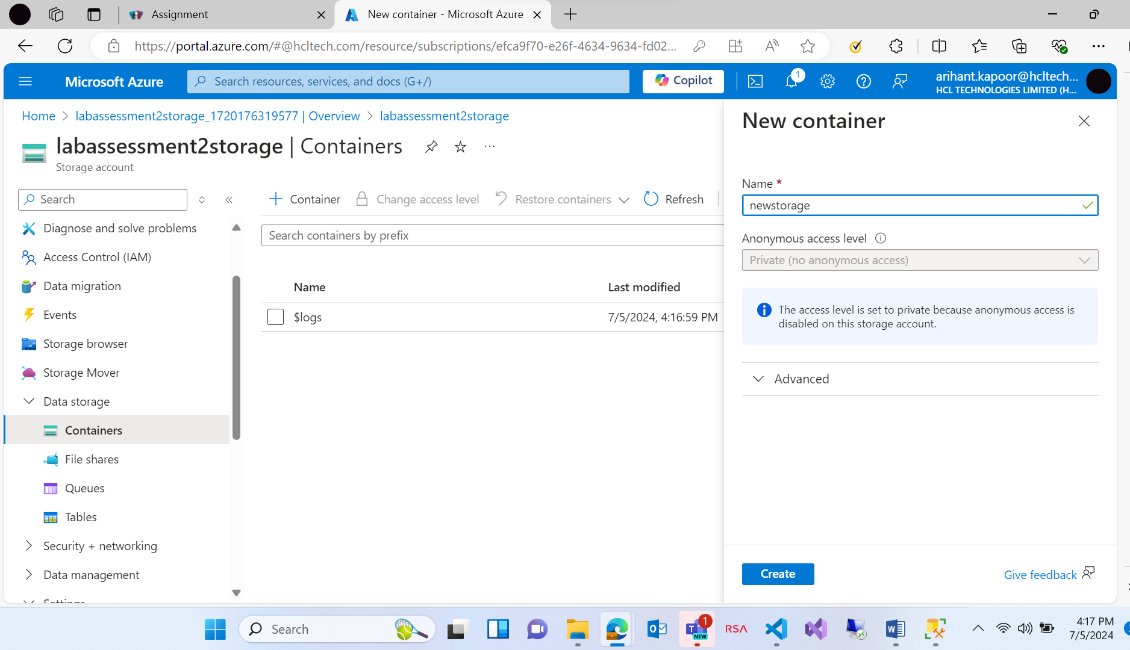

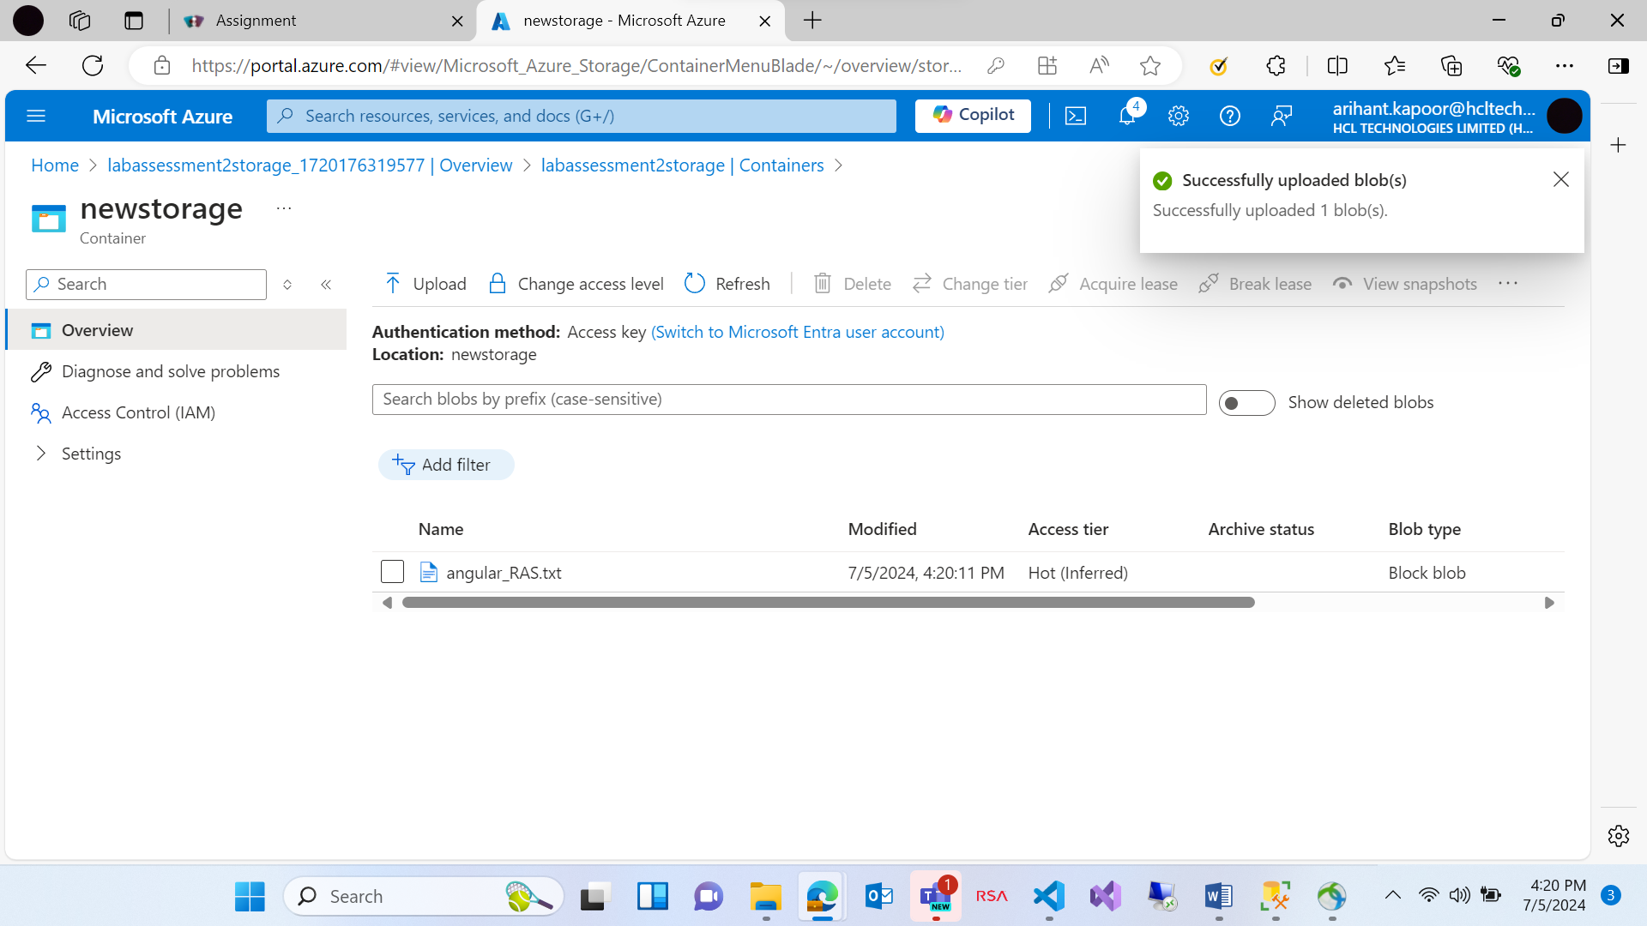

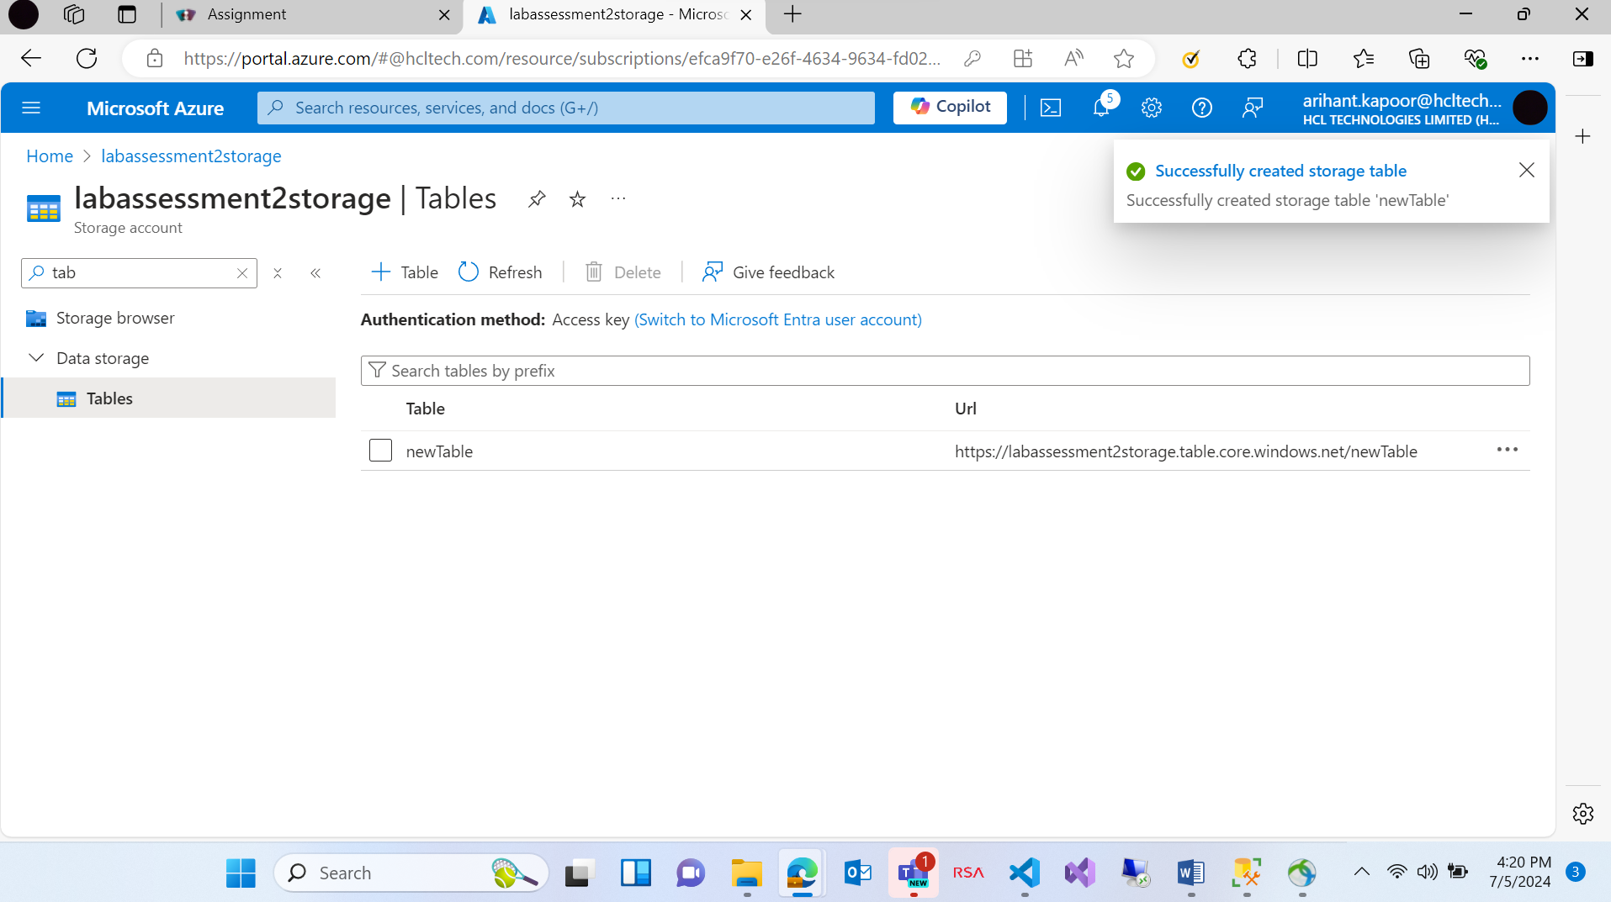

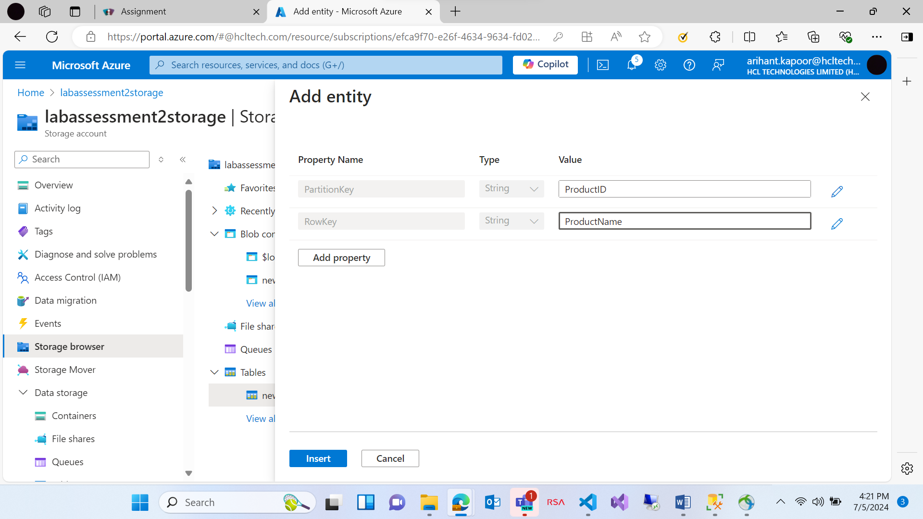

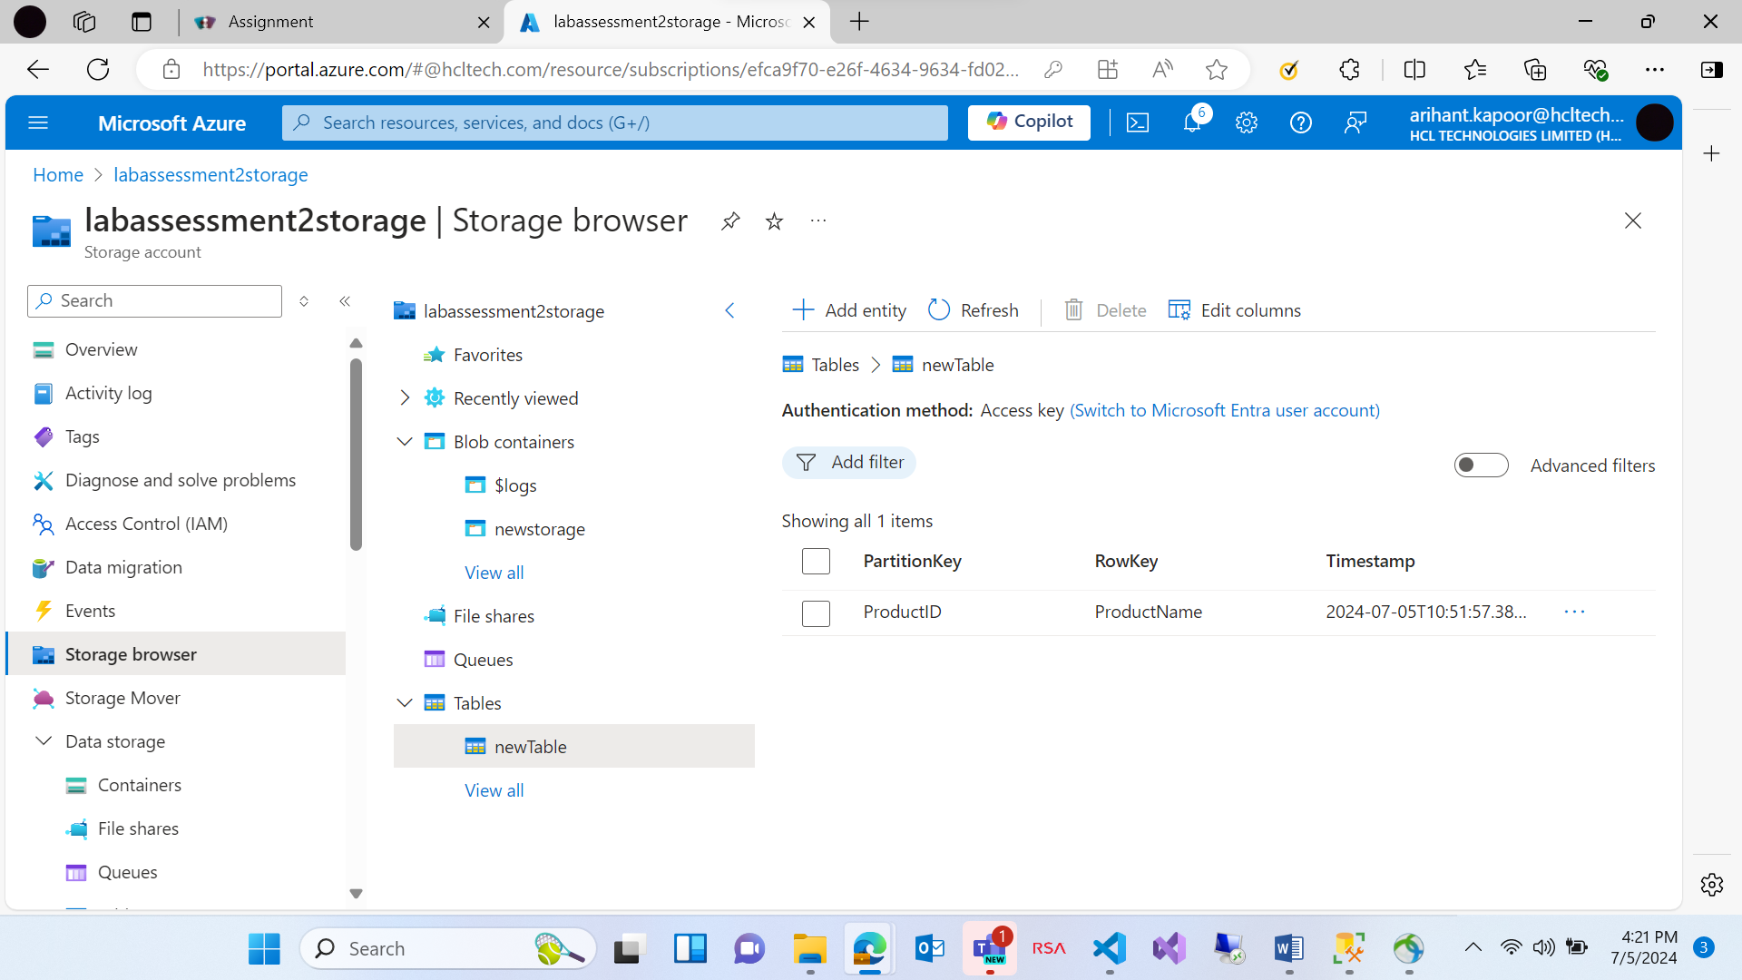

Creating a web app in Azure portal

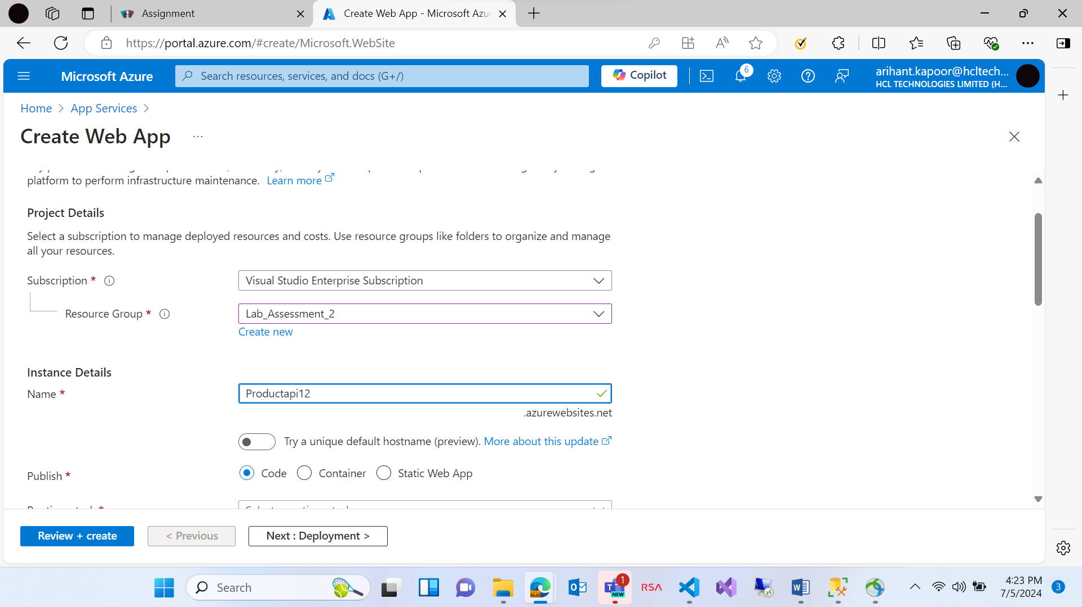

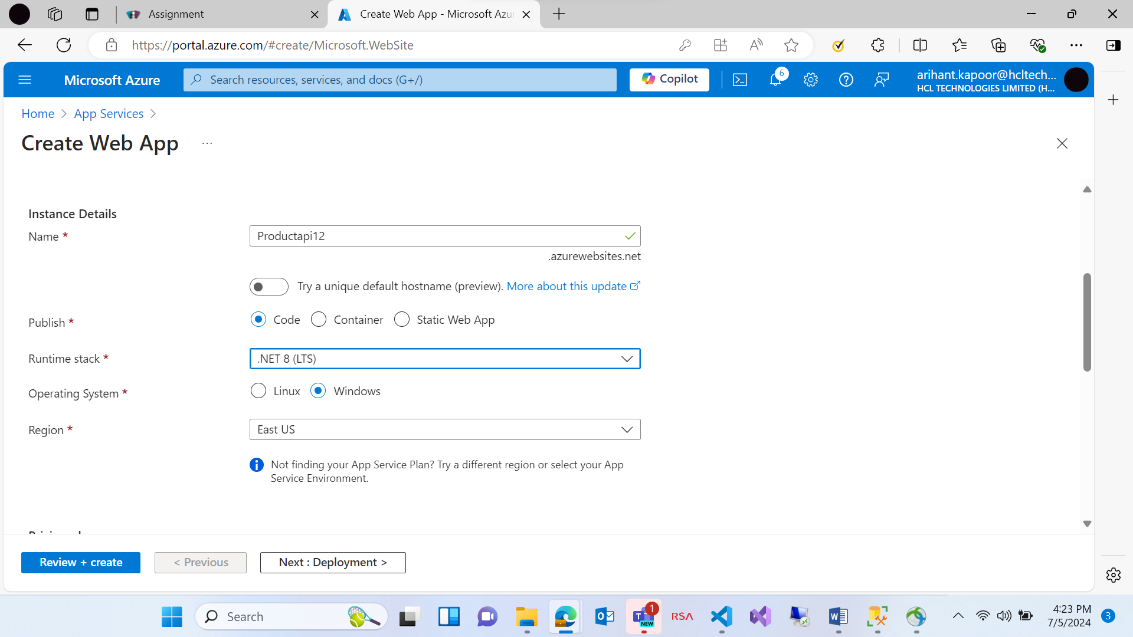

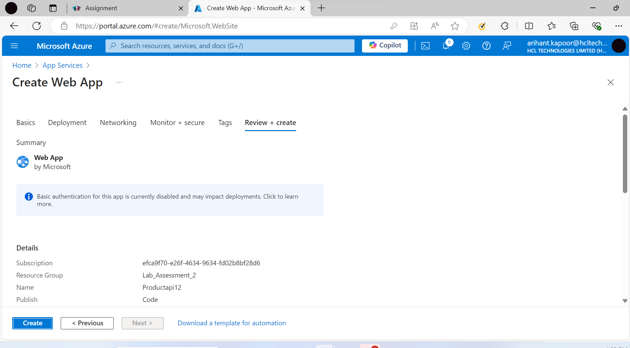

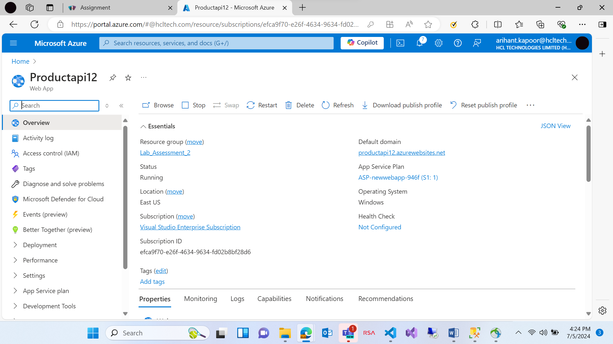

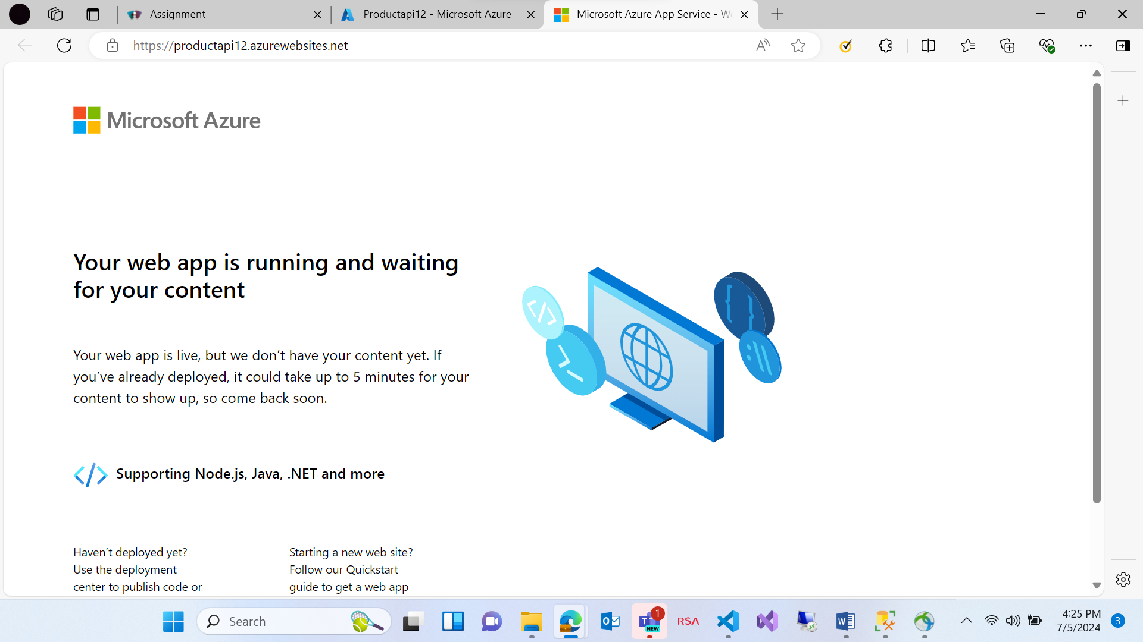

After use, please stop the app, to save your cost/credits.

